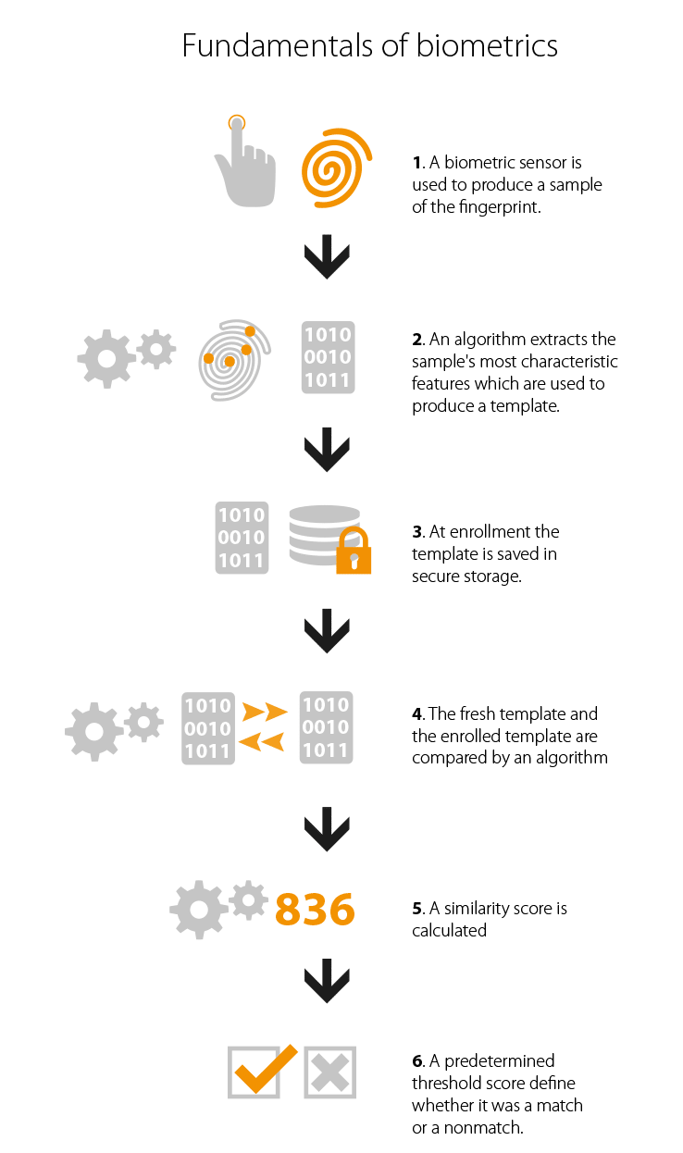

The Data Flow Diagram

**Filtering take minuties**

**FAKE**

**VALID**

**Database**

**Scaling the length of the image**

**Remove**

**Background**

**Images**

**Save Image as Identifier**

**User**